### Project Report

### INT 217

**Project**

#### LOVELY PROFESSIONAL UNIVERSITY PHAGWARA, PUNJAB



**Market-wise Commodity Price Analysis Across Indian States**

**SUBMITTED BY -** Rishabh Rana

**Registration Number:** 12311471

**Section** – K23GW

**Roll no**- 16

### Ensured numeric columns were formatted correctly for accurate aggregation.

1. Analysis on Dataset :-
2. **High concentration in mid-price ranges:**
   * Most commodities and markets are clustered in the **2,000 to 4,000 INR** range.
   * Especially around **2725** and **2926 INR**, there's a **sharp spike**, indicating that these prices are very common across the dataset.
3. **Peak frequency:**
   * The tallest bar for "Count of Market" is around **2725 INR**, suggesting that many **markets had this price** for their commodities.
   * Similarly, high "Count of Commodity" at 2222, 2425, and 3260 INR suggests these price points were commonly recorded across **various commodities**.
4. **Commodity counts dominate:**
   * The blue bars (commodities) are generally higher than the orange ones (markets), which makes sense as multiple commodities can be reported per market per day.

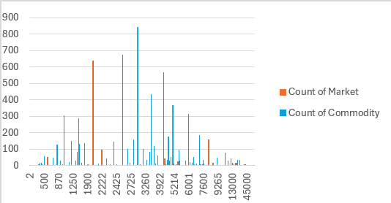

Objective 2 **Local Grade Dominates:**

* The **Local** grade has an overwhelmingly high total price—around **₹32–33 million**. This suggests that a large portion of the commodities in the dataset were categorized under "Local", possibly due to its broader or more frequently used classification.

**FAQ Grade is Second Highest:**

* The **FAQ** (Fair Average Quality) grade, a commonly used standard in agricultural markets, comes next but is significantly lower than "Local".

**Other Grades Are Minimal:**

* Grades like **Large**, **Medium**, **Non-FAQ**, and **Small** have **very low total price values** in comparison. This could be due to:
  + Fewer entries in these categories.
  + Lower individual prices.
  + Less frequently used grading labels.

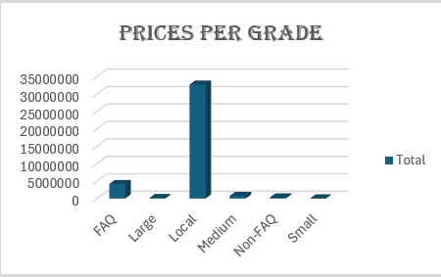

Objective 3 **Top 10 States Sales**

**Telangana is Dominant:**

* Telangana shows a massive spike in total sales, close to **₹35 million**, far exceeding any other state.
* This suggests that either:
  + A large volume of transactions was recorded in Telangana.
  + Higher-priced commodities were traded there.
  + Or both.

**Other States Have Significantly Lower Sales:**

* States like **West Bengal**, **Uttar Pradesh**, **Rajasthan**, and **Odisha** show very small bars, indicating **much lower total sales**.
* Even **large agricultural states** like **Maharashtra** and **Andhra Pradesh** show relatively low totals, which might be due to:
  + Fewer data entries.
  + Lower average commodity prices.
  + Less variety or volume in the dataset for those regions.

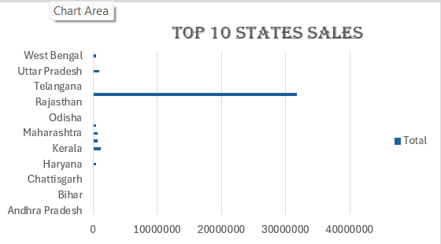

#### Objective State Prices

#### Andhra Pradesh Dominates:

#### The sky-blue slice (Andhra Pradesh) covers the vast majority of the pie chart, indicating that most of the total recorded prices in this dataset come from Andhra Pradesh.

#### This could mean:

#### A high number of transactions were recorded in that state.

#### Commodities were priced higher.

#### Or the dataset might be heavily skewed toward Andhra Pradesh’s markets.

#### Other States Have Minor Shares:

#### States like Assam, Bihar, Chandigarh, and others have very small slices, contributing only a small fraction of the total prices.

#### This suggests relatively lower market activity or fewer data entries from these regions in the dataset.

#### 

#### Objective Order Types

#### "Local" Grade Dominates:

#### The blue slice representing Local covers the vast majority of the chart.

#### This means most of the commodity entries in the dataset are labeled under the "Local" grade.

#### It likely reflects either:

#### A broad classification commonly used in the markets.

#### Or an overrepresentation in the dataset.

#### "FAQ" Grade is Second:

#### The green slice represents the FAQ (Fair Average Quality) grade and is the second largest portion.

#### It’s a widely used standard in agricultural markets and holds a significant but much smaller share compared to "Local".

#### All Other Grades Are Minimal:

#### Grades like Medium, Non-FAQ, Small, and Large appear as tiny slivers, indicating they’re rarely used or recorded in this dataset.

#### 

1. Conclusion :-  
   The analysis of the dataset reveals significant insights into the distribution, pricing, and classification of commodities across Indian states. It is evident that certain grades such as “Local” dominate the market in both volume and value, while Andhra Pradesh and Telangana emerge as the leading contributors in terms of total sales. Furthermore, the presence of stark disparities in the number of entries and prices across different states and grades suggests either regional trade concentration or limitations in data representation. The dataset also highlights the overwhelming use of specific grading types, indicating possible standardization issues or regional labeling preferences.
2. Future Scope  
   This dataset offers immense potential for further exploration and development across multiple dimensions. A key future scope lies in conducting time-series analysis to uncover seasonal patterns and price fluctuations of commodities, which can assist in better forecasting and decision-making for farmers and policymakers. There is also scope to standardize and assess the impact of commodity grading systems, which currently show uneven representation and could benefit from uniform policies. Lastly, aligning the insights from this dataset with government programs like MSP (Minimum Support Price) or market reform initiatives can lead to more data-driven agricultural policies, thereby enhancing market transparency and farmer welfare.

7. References :

1.ElectionCommisionofIndia:  
<https://www.data.gov.in/catalogs?highvalue=0>

2.GeneralLokSabha   
<https://jalshakti-dowr.gov.in/>

3. Microsoft Excel Official Documentation  
<https://support.microsoft.com/en-us/excel>

4. Article: Best Practices for Data Visualization in Data analysis  
<https://www.frontiersin.org/articles/10.3389/fenvs.2020.00036/full>